Devops:-

Git:-

CVCS

VS

DVCS

Repository :

Commit:

Setting up git:

Commands :

Configuration: 1. git config –global user.name “ username”

2. git config –global user.mail “email id”

Configure our first repo:

mkdir

cd to directory

git init

git status

git commit –m “this coment”

git add mail.txt

git status

git log :-

git diff

git clone “giturl”

git push

1.“how can we add more number of file at a time “

git pull

git remote add origin <repository name>

git checkout –test.py

What is a branch: -

git checkout –b <name of the branch>

git checkout <branch name>

git merge <branch name>

Rebase:

git rebase –i

hosting reposi

Linux

>Download and install oracle virtual box

>Download and install vagrant

>we need to run ruby file

Using “vagrant up” in cmd at file location

>sign up into “aws management server”

>Ec2

>instances

>lounchences

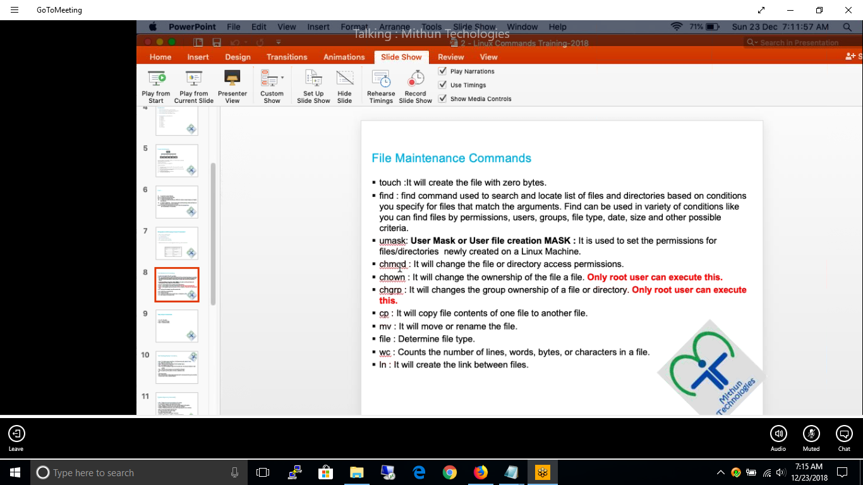

* Monitoring the server’s and services using Sensu and Load Balancing tool HAProxy.
* Escalated mail to respective team if any critical alert’s observed in sensu.
* If any down alert’s camed from Pingdom, escalated that mail’s to systems team and follow up until it’s resolved.
* If any services are down in sensu, browsing that service’s by pointing that locally. and If the service is not browsing well, then informed to respective team.
* Informed to systems team if the server go’s down multiple times within a day.
* Informed to on call person’s quickly regarding issues.
* Got appreciation from Mr.Kannaiah regarding quick response .

I would like to develop skills towards DevOps Engineer with scripting language’s Python and Ruby to automate some tasks. And solve some issues which are coming regularly.